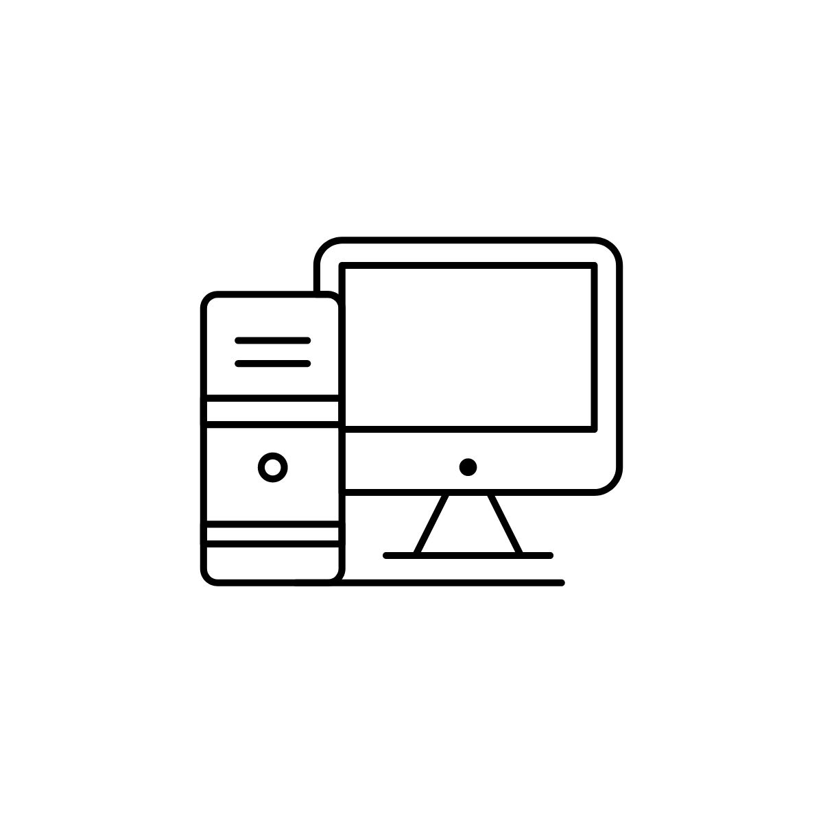
COMPUTER
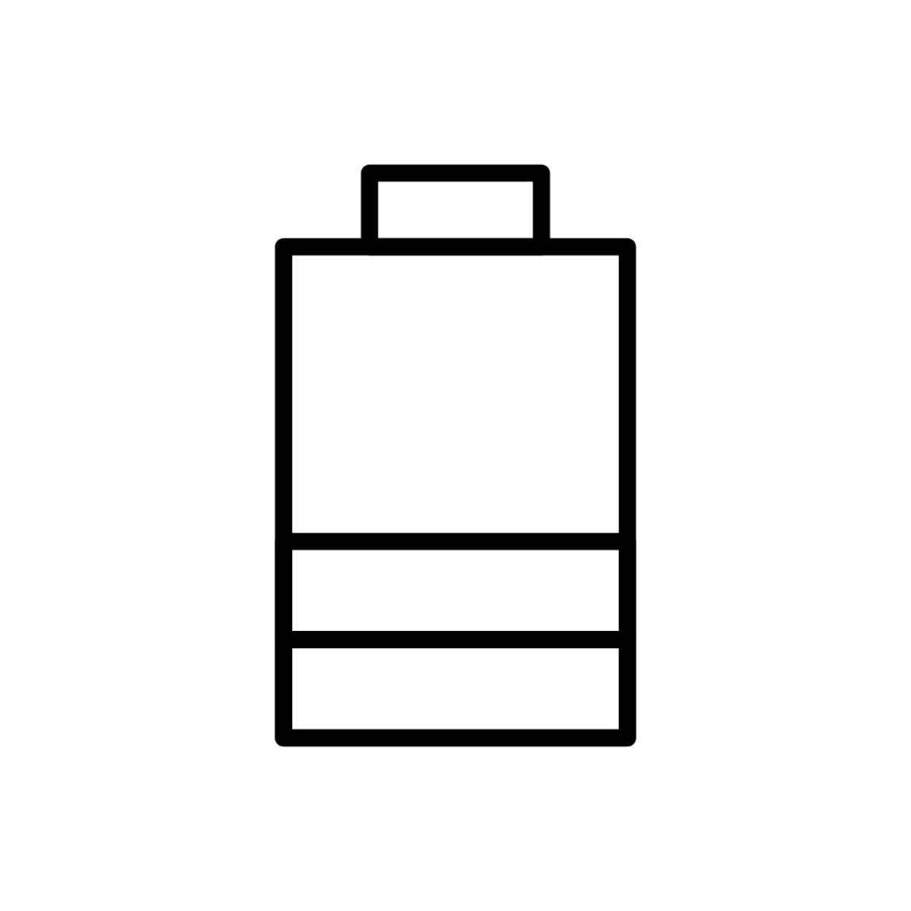
STROM
WLAN
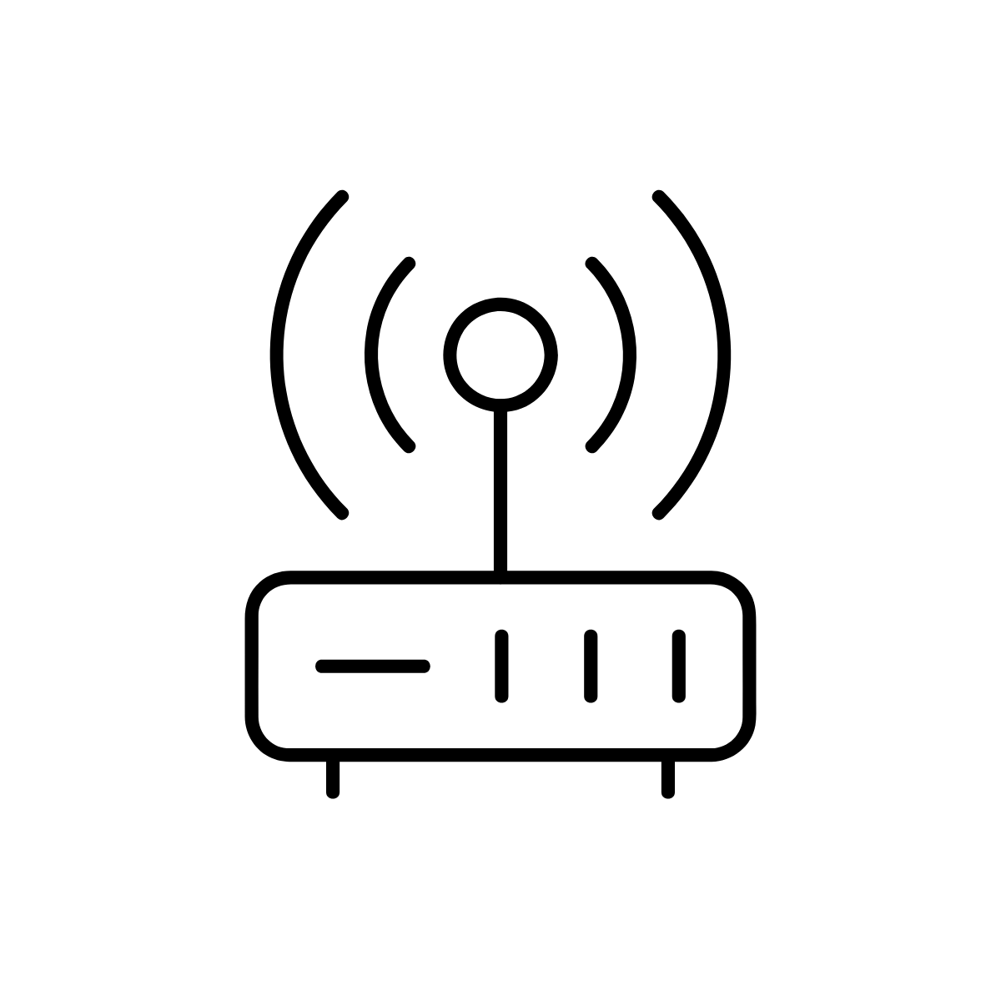
ROUTER
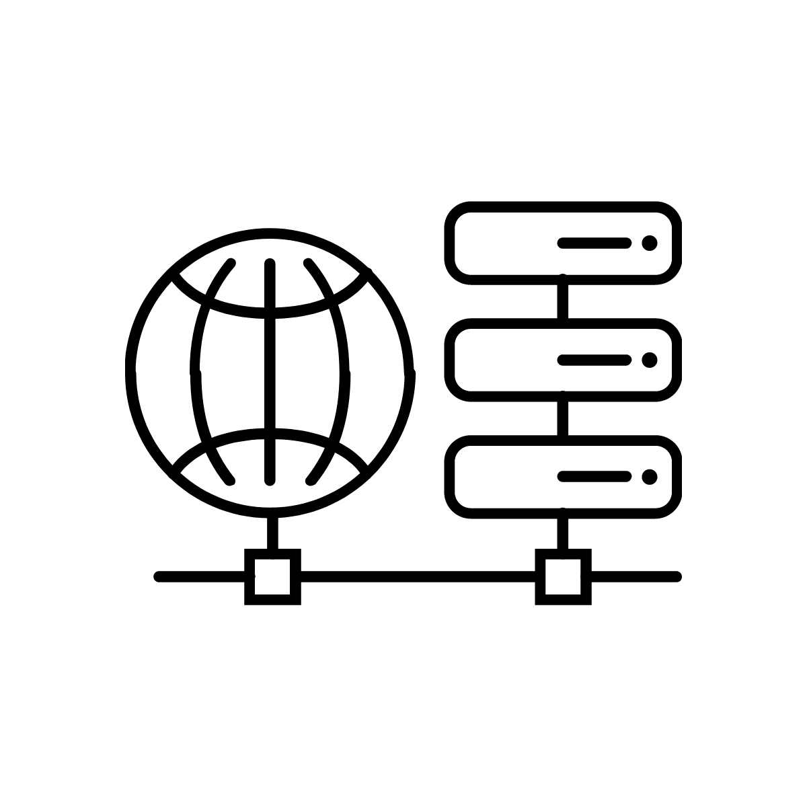
ISP
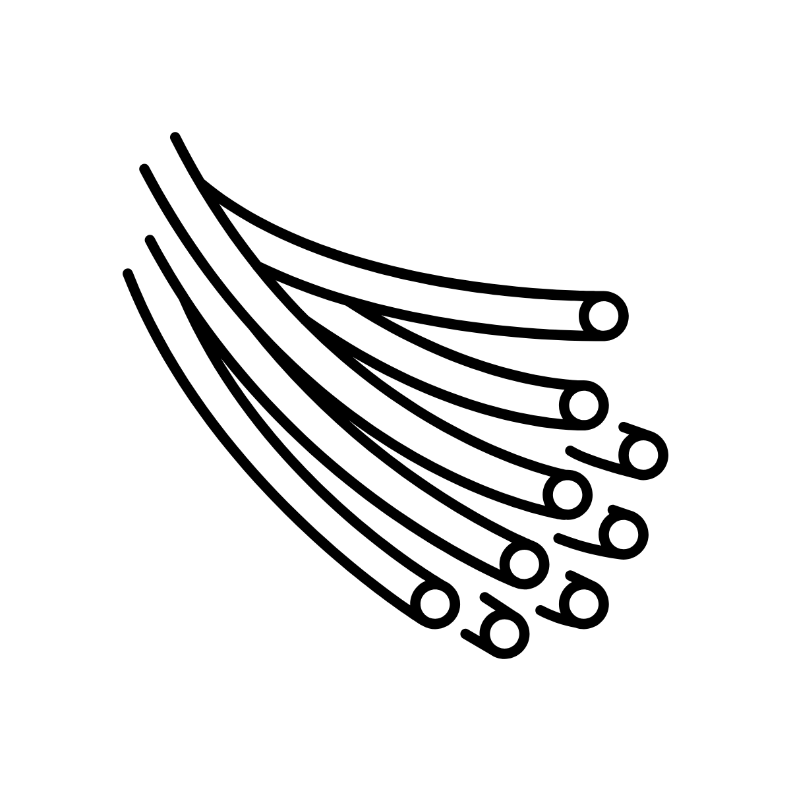
UNTERSEEKABEL
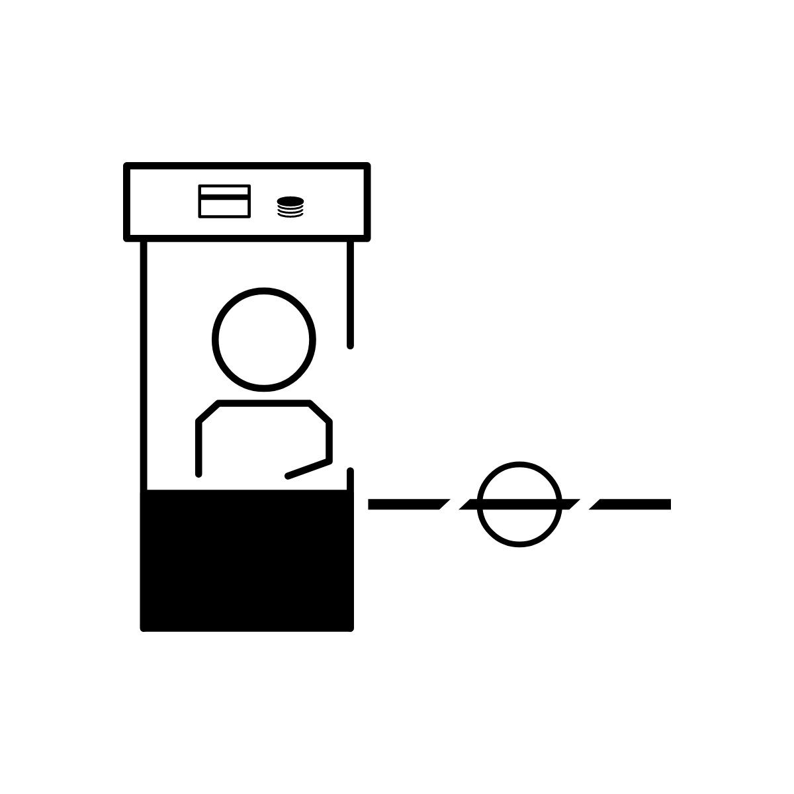
LÄNDERGRENZE
BROWSER

URL

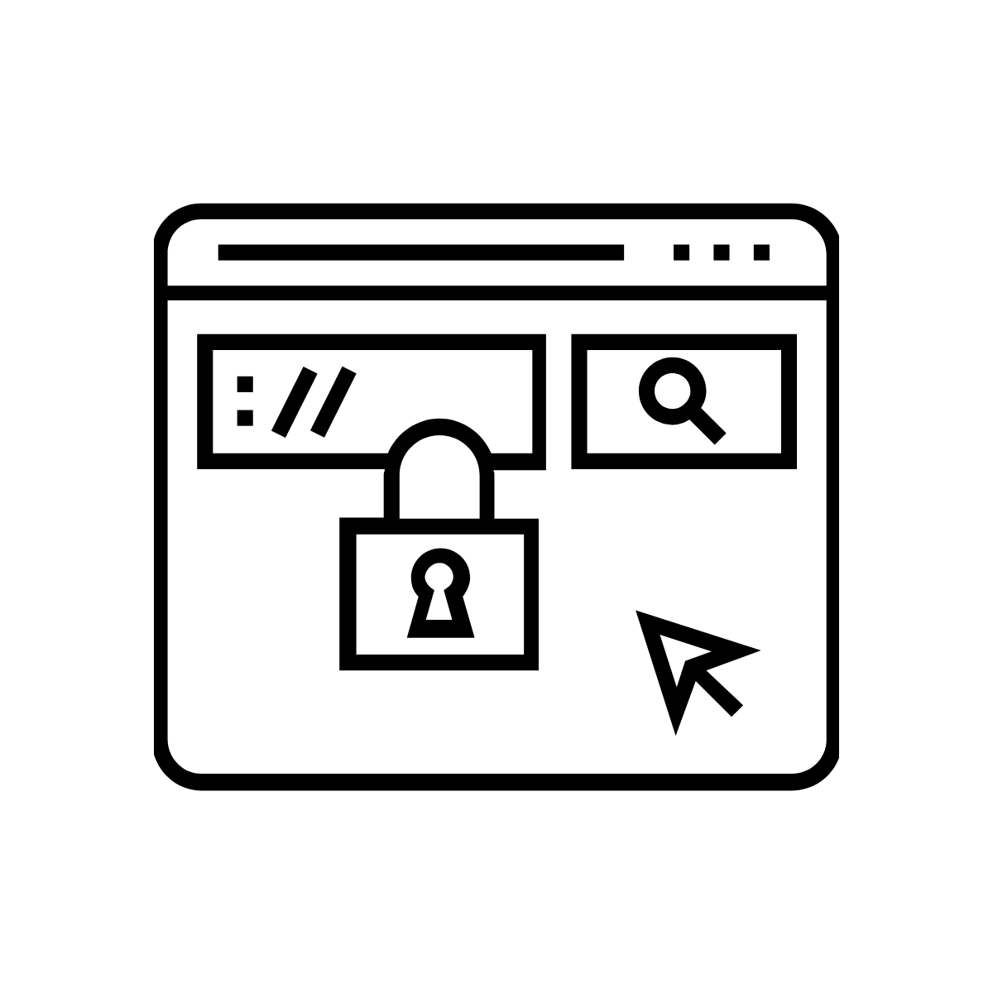
HTTP
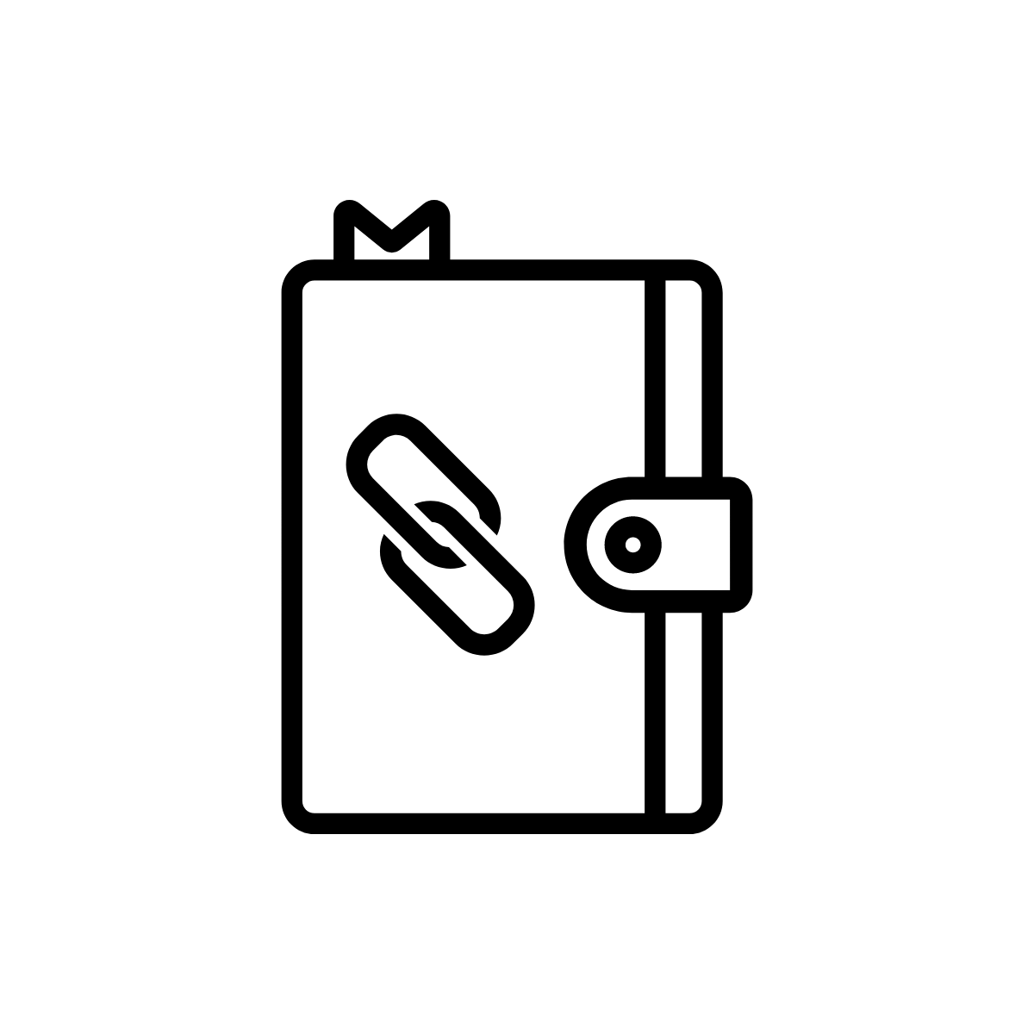
DNS
SERVER
WEBSITE-BETREIBER
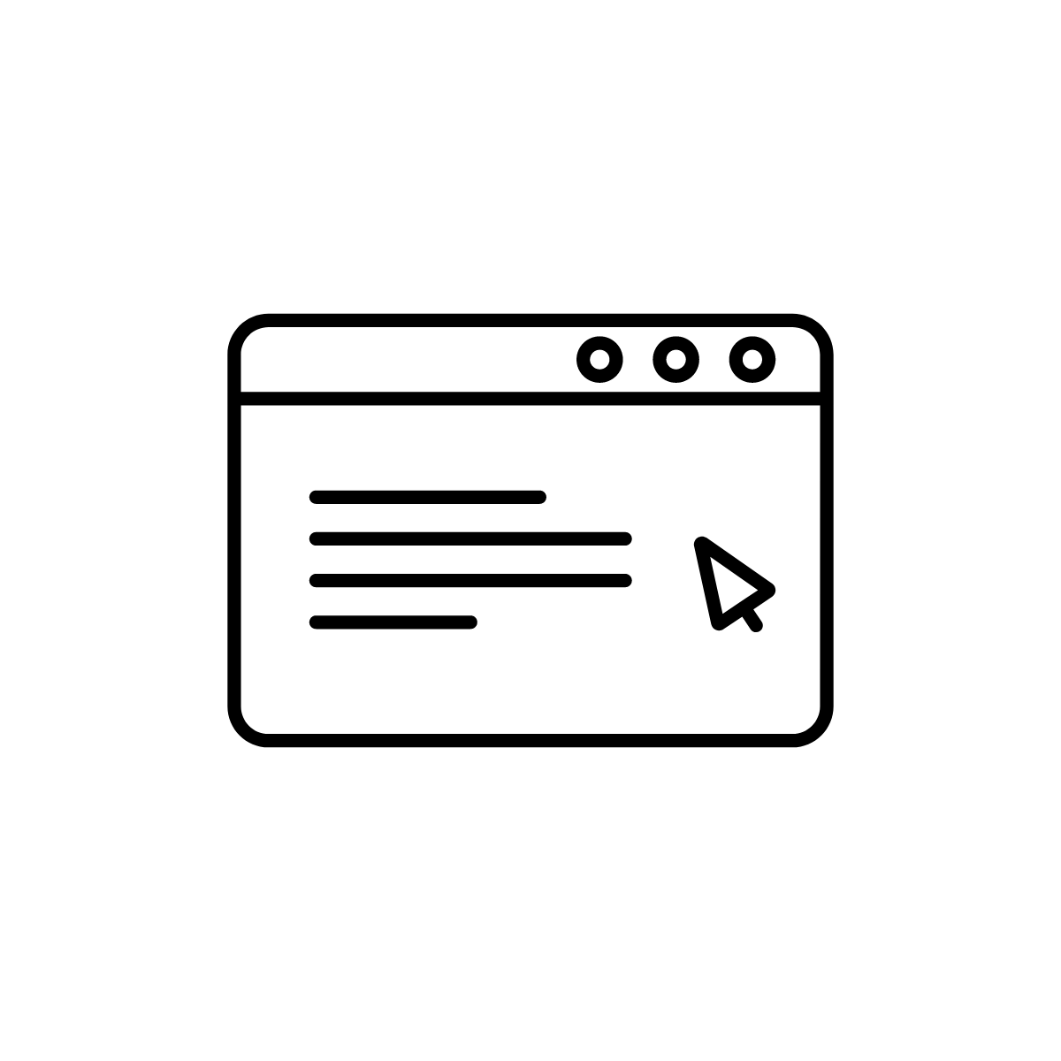
WEBSITE
Lizenz
Dieses Werk ist lizenziert unter einer Creative Commons Namensnennung - Weitergabe unter gleichen Bedingungen 4.0 International Lizenz. Die Icons wurden für das Projekt zur lizenzfreien Nutzung erworben. Sie können auf der Website https://thenounproject.com/ aber auch bei Angabe der Credits unter der Creative Commons-Lizenz CC By frei runtergeladen werden. Deshalb hat das F3_kollektiv zusätzlich ein Verzeichnis mit den Credit-Angaben erstellt:
- Computer
personal computer by Grafix Point from the Noun Project
https://thenounproject.com/search/?q=2961764&i=2961764
- Akku
Battery by Flatart from the Noun Project
https://thenounproject.com/search/?q=2916510&i=2916510
- WLAN
wifi signal by icon 54 from the Noun Project
https://thenounproject.com/search/?q=2059193&i=2059193
- Router
Router by shashank singh from the Noun Project
https://thenounproject.com/search/?q=1989868&i=1989868
- Unterseekabel
optical fiber by Fabio Rinaldi from the Noun Project
https://thenounproject.com/search/?q=2914079&i=2914079
- ISP
service by Andrei Yushchenko from the Noun Project
https://thenounproject.com/search/?q=3124587&i=3124587
- Ländergrenze
Toll Booth by 8TIES® from the Noun Project https://thenounproject.com/search/?q=toll%20booth&i=590581
- Browser
Browser by rivercon from the Noun Project
https://thenounproject.com/search/?q=Browser&i=2562438
- URL
url by LAFS from the Noun Project
https://thenounproject.com/search/?q=URL&i=2191834
- HTTP
https by Creative Stall from the Noun Project
https://thenounproject.com/search/?q=http&i=995746
- DNS
Notebook by iconpacks from the Noun Project
https://thenounproject.com/search/?q=adress%20book&i=2298791
- Server
Server by Tippawan Sookruay from the Noun Project
https://thenounproject.com/search/?q=server&i=3385300
- Website-Betreiber
company by iconix user from the Noun Project
https://thenounproject.com/search/?q=company&i=3131044
- Website
website by Maxicons from the Noun Project
https://thenounproject.com/search/?q=Website&i=1832494

